GrantOS Operating System

Technical Documentation v1.0

Table of Contents
- Project Overview
- Architecture Documentation
- Build System Documentation
- API Reference
- Memory Management
- Input/Output Systems
- Boot Process
- Development Guidelines
- Testing Documentation
- Troubleshooting Guide

Project Overview

Mission Statement
GrantOS is a modern, educational 64-bit operating system designed to demonstrate fundamental OS concepts while maintaining clean, readable code architecture.

Key Features
- 64-bit Architecture: Full x86_64 support with long mode
- Memory Management: Custom kernel memory allocator
- Interactive Shell: Command-line interface with built-in commands
- Hardware Abstraction: Modular driver architecture
- Educational Focus: Well-documented code for learning purposes

System Requirements

Hardware Requirements
- Processor: x86_64 compatible CPU
- Memory: Minimum 16MB RAM
- Storage: 10MB available space
- Display: VGA-compatible display adapter

Development Requirements
- Host OS: Linux (Ubuntu 18.04+ recommended)
- Cross Compiler: x86_64-elf-gcc
- Assembler: NASM 2.14+
- Bootloader: GRUB 2.0+
- Emulator: QEMU 4.0+
- Container: Docker (optional)

Architecture Documentation

System Architecture Overview
┌─────────────────────────────────────────────────────────────┐
│ USER SPACE │
│ GrantOS Shell │
├─────────────────────────────────────────────────────────────┤
│ KERNEL SPACE │
│ ┌─────────────────┐ ┌─────────────────┐ ┌───────────────┐ │
│ │ Memory Mgmt │ │ I/O Systems │ │ Drivers │ │
│ │ - kmalloc │ │ - VGA Output │ │ - Keyboard │ │
│ │ - kfree │ │ - String Ops │ │ - Timer │ │
│ │ - Heap Mgmt │ │ - Print Sys │ │ - Hardware │ │
│ └─────────────────┘ └─────────────────┘ └───────────────┘ │
├─────────────────────────────────────────────────────────────┤
│ HARDWARE LAYER │
│ x86_64 CPU | Memory | VGA | Keyboard │
└─────────────────────────────────────────────────────────────┘

Directory Structure
GrantOS/
├── src/
│ ├── impl/
│ │ ├── kernel/ # Core kernel implementation
│ │ │ ├── main.c # Kernel entry point
│ │ │ └── memory/ # Memory management
│ │ │ ├── memory.c
│ │ │ └── memory.h
│ │ ├── utils/ # Utility functions
│ │ │ └── string.c # String operations
│ │ └── x86_64/ # Architecture-specific code
│ │ ├── boot/ # Boot process
│ │ │ ├── header.asm
│ │ │ ├── main.asm
│ │ │ └── main64.asm
│ │ ├── keyboard.c # Keyboard driver
│ │ ├── print.c # VGA output driver
│ │ └── io.h # Hardware I/O operations
│ └── intf/ # Interface headers
│ ├── keyboard.h
│ ├── print.h
│ └── string.h
├── targets/
│ └── x86_64/
│ ├── linker.ld # Linker script
│ └── iso/
│ └── boot/
│ └── grub/
│ └── grub.cfg
├── build/ # Build artifacts
├── dist/ # Distribution files
├── Makefile # Build configuration
└── Dockerfile # Development environment

Component Relationships
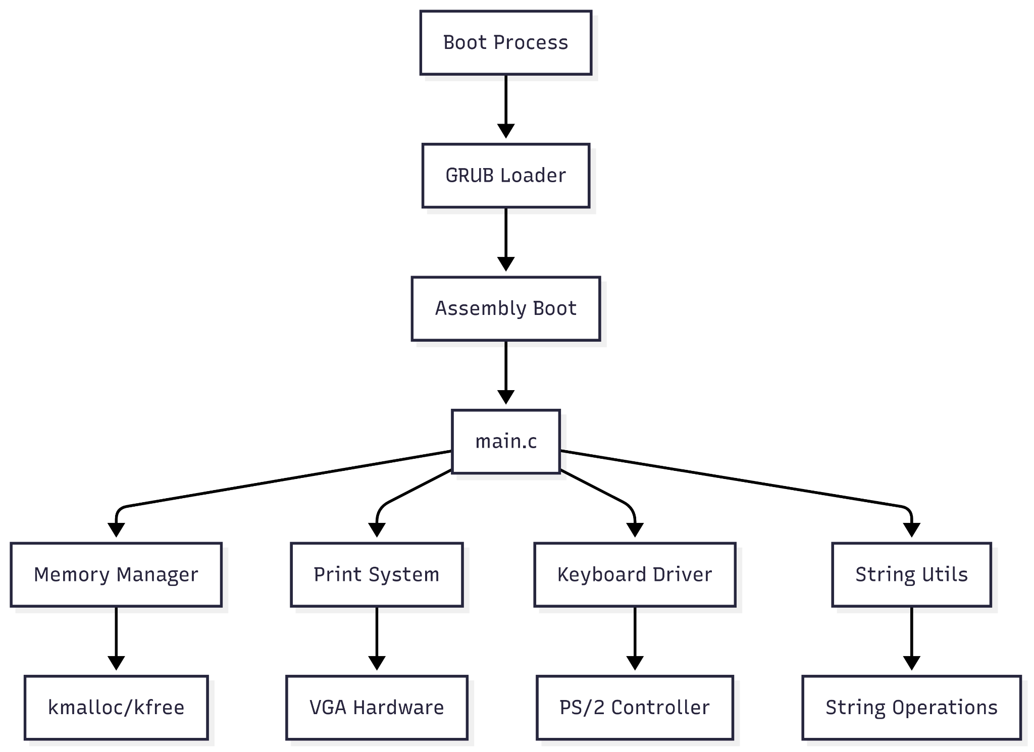

Build System Documentation

Prerequisites Installation

Ubuntu/Debian
# Install cross-compilation tools
sudo apt-get update
sudo apt-get install build-essential
sudo apt-get install gcc-multilib
sudo apt-get install nasm
sudo apt-get install xorriso
sudo apt-get install grub-pc-bin
sudo apt-get install grub-common
sudo apt-get install qemu-system-x86

# Install cross-compiler
wget https://github.com/lordmilko/i686-elf-tools/releases/download/7.1.0/x86_64-elf-tools-linux.zip
unzip x86_64-elf-tools-linux.zip
export PATH="$PATH:/path/to/x86_64-elf-tools-linux/bin"

Docker Environment
# Build development environment
docker build -t grantos-dev .

# Run development container
docker run -it --rm -v $(pwd):/root/env grantos-dev

Build Process

Standard Build
# Clean build
make clean

# Build kernel binary
make build-x86_64

# Build ISO image
make iso

# Run in QEMU
qemu-system-x86_64 -cdrom dist/x86_64/kernel.iso

Build Targets
Target | Description | Output
build-x86_64 | Build kernel binary and ISO | dist/x86_64/kernel.bin, dist/x86_64/kernel.iso
clean | Remove build artifacts | -
debug | Build with debug symbols | dist/x86_64/kernel-debug.bin
test | Run automated tests | Test results

Makefile Variables
# Compiler Configuration
CC = x86_64-elf-gcc
CFLAGS = -ffreestanding -Wall -Wextra -std=c11
LDFLAGS = -nostdlib -lgcc

# Assembler Configuration
AS = nasm
ASFLAGS = -f elf64

# Directories
BUILD_DIR = build
DIST_DIR = dist
SRC_DIR = src

Build Dependencies
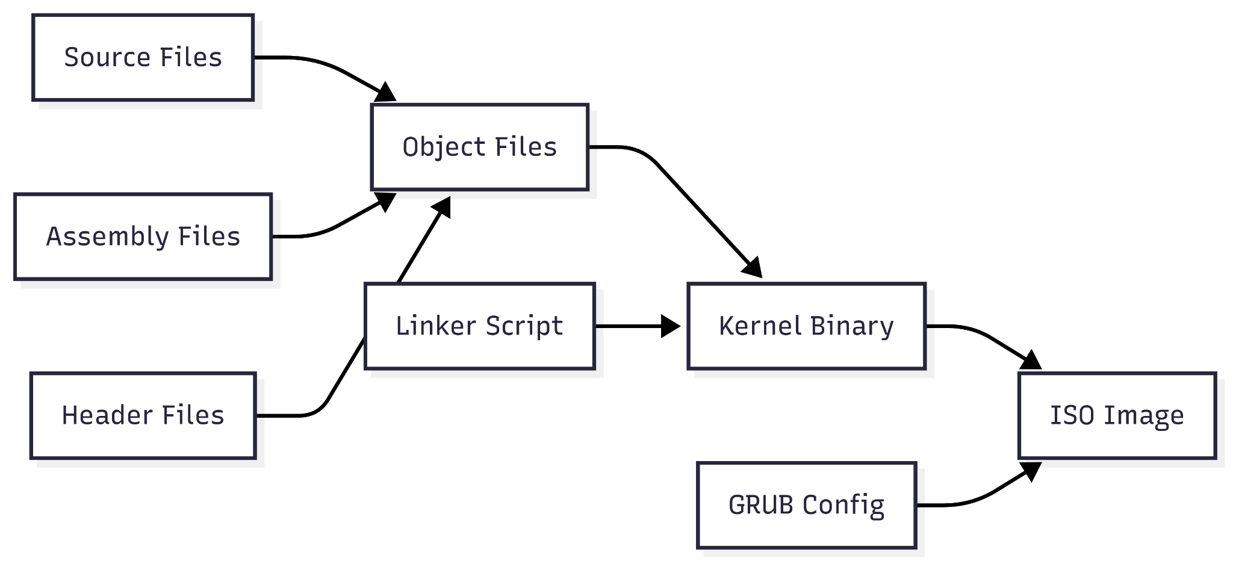

API Reference

Core Kernel API

Memory Management API
/**
* @file memory.h
* @brief Kernel memory management interface
*/

/**
* @brief Initialize kernel memory management system
* @param mem_size Total memory size in bytes
* @return void
*/
void memory_init(uint64_t mem_size);

/**
* @brief Allocate kernel memory
* @param size Number of bytes to allocate
* @return void* Pointer to allocated memory, NULL on failure
* @note Memory is aligned to 16-byte boundaries
* @warning Caller must check for NULL return value
*/
void* kmalloc(size_t size);

/**
* @brief Free previously allocated kernel memory
* @param ptr Pointer to memory to free
* @return void
* @note Passing NULL is safe and does nothing
* @warning Double-free will cause undefined behavior
*/
void kfree(void* ptr);

/**
* @brief Get current memory usage statistics
* @param info Pointer to structure to fill with memory info
* @return void
*/
void memory_get_info(memory_info_t* info);

Memory Management Types
/**
* @brief Memory usage information structure
*/
typedef struct {
uint64_t total_memory; /**< Total available memory in bytes */
uint64_t used_memory; /**< Currently used memory in bytes */
uint64_t free_memory; /**< Currently free memory in bytes */
} memory_info_t;

Display System API

Print System Interface
/**
* @file print.h
* @brief VGA text mode display interface
*/

/**
* @brief Clear entire screen and reset cursor
* @return void
*/
void print_clear(void);

/**
* @brief Print single character to screen
* @param character Character to print
* @return void
* @note Handles special characters: \n, \b
*/
void print_char(char character);

/**
* @brief Print null-terminated string to screen
* @param string String to print
* @return void
* @warning String must be null-terminated
*/
void print_str(char* string);

/**
* @brief Print string with custom colors
* @param string String to print
* @param foreground Foreground color (PRINT_COLOR_*)
* @param background Background color (PRINT_COLOR_*)
* @return void
*/
void print_str_color(char* string, uint8_t foreground, uint8_t background);

/**
* @brief Set default text colors
* @param foreground Foreground color
* @param background Background color
* @return void
*/
void print_set_color(uint8_t foreground, uint8_t background);

Color Constants
enum {
PRINT_COLOR_BLACK = 0, /**< Black color */
PRINT_COLOR_BLUE = 1, /**< Blue color */
PRINT_COLOR_GREEN = 2, /**< Green color */
PRINT_COLOR_CYAN = 3, /**< Cyan color */
PRINT_COLOR_RED = 4, /**< Red color */
PRINT_COLOR_MAGENTA = 5, /**< Magenta color */
PRINT_COLOR_BROWN = 6, /**< Brown color */
PRINT_COLOR_LIGHT_GRAY = 7, /**< Light gray color */
PRINT_COLOR_DARK_GRAY = 8, /**< Dark gray color */
PRINT_COLOR_LIGHT_BLUE = 9, /**< Light blue color */
PRINT_COLOR_LIGHT_GREEN = 10, /**< Light green color */
PRINT_COLOR_LIGHT_CYAN = 11, /**< Light cyan color */
PRINT_COLOR_LIGHT_RED = 12, /**< Light red color */
PRINT_COLOR_PINK = 13, /**< Pink color */
PRINT_COLOR_YELLOW = 14, /**< Yellow color */
PRINT_COLOR_WHITE = 15 /**< White color */
};

Input System API

Keyboard Interface
/**
* @file keyboard.h
* @brief PS/2 keyboard driver interface
*/

/**
* @brief Read character from keyboard
* @return char ASCII character, 0 if no key pressed
* @note Non-blocking function
* @note Handles shift, caps lock modifiers
*/
char keyboard_read_char(void);

Utility Functions API

String Operations
/**
* @file string.h
* @brief String manipulation utilities
*/

/**
* @brief Compare two null-terminated strings
* @param str1 First string to compare
* @param str2 Second string to compare
* @return int 0 if equal, <0 if str1 < str2, >0 if str1 > str2
* @note Comparison is lexicographic
*/
int str_compare(const char* str1, const char* str2);

Hardware I/O API

Port I/O Operations
/**
* @file io.h
* @brief Hardware I/O port operations
*/

/**
* @brief Read byte from I/O port
* @param port Port address to read from
* @return uint8_t Value read from port
*/
static inline uint8_t inb(uint16_t port);

/**
* @brief Write byte to I/O port
* @param port Port address to write to
* @param val Value to write to port
* @return void
*/
static inline void outb(uint16_t port, uint8_t val);

/**
* @brief Shutdown QEMU emulator
* @return void
* @note Only works in QEMU environment
*/
static inline void qemu_shutdown(void);

Memory Management

Overview
GrantOS implements a simple but effective kernel memory allocator using a linked-list approach with first-fit allocation strategy.

Memory Layout
Virtual Memory Layout (x86_64):
┌─────────────────────────────────────────────────┐ 0xFFFFFFFFFFFFFFFF
│ Kernel Space │
├─────────────────────────────────────────────────┤ 0xFFFF800000000000
│ │
│ User Space │
│ │
├─────────────────────────────────────────────────┤ 0x0000800000000000
│ Non-canonical │
├─────────────────────────────────────────────────┤ 0x00007FFFFFFFFFFF
│ User Space │
│ │
├─────────────────────────────────────────────────┤ 0x0000000000400000
│ Kernel Heap │ (HEAP_START)
├─────────────────────────────────────────────────┤ 0x0000000000100000
│ Kernel Code/Data │ (1MB)
├─────────────────────────────────────────────────┤ 0x0000000000000000
│ Low Memory │
└─────────────────────────────────────────────────┘

Allocation Algorithm

Block Structure
typedef struct block {
size_t size; /**< Size of data area */
int is_free; /**< Free flag (1=free, 0=used) */
struct block* next; /**< Next block in list */
} block_t;

Allocation Process
- Size Alignment: Round up to 16-byte boundary
- Block Search: Linear search for suitable free block
- Splitting: Split large blocks when possible
- Linking: Update linked list pointers

Deallocation Process
- Validation: Check pointer validity
- Marking: Mark block as free
- Coalescing: Merge adjacent free blocks
- Statistics: Update memory usage counters

Memory Statistics
typedef struct {
uint64_t total_memory; // Total heap size
uint64_t used_memory; // Currently allocated
uint64_t free_memory; // Currently available
} memory_info_t;

Usage Examples
// Initialize memory subsystem
memory_init(16 * 1024 * 1024); // 16MB

// Allocate memory
void* buffer = kmalloc(1024);
if (buffer == NULL) {
// Handle allocation failure
print_str("Memory allocation failed!\n");
return;
}

// Use memory
char* str_buffer = (char*)buffer;
// ... use buffer ...

// Free memory
kfree(buffer);
buffer = NULL; // Prevent double-free

// Get memory statistics
memory_info_t info;
memory_get_info(&info);
print_str("Memory used: ");
// ... print statistics ...

Input/Output Systems

VGA Text Mode Display

Technical Specifications
- Resolution: 80x25 characters
- Memory Location: 0xB8000
- Character Format: 16-bit (8-bit character + 8-bit attribute)
- Color Depth: 4-bit foreground + 4-bit background

Character Attribute Format
Bit: 7 6 5 4 3 2 1 0
Field: [B] [BG ] [FG ]
│ │ └─ Foreground color (0-15)
│ └─ Background color (0-7)
└─ Blink bit

Cursor Management
The system maintains hardware cursor position using VGA CRTC registers:
- Port 0x3D4: Index register
- Port 0x3D5: Data register
- Index 0x0E: Cursor location high byte
- Index 0x0F: Cursor location low byte

Keyboard Input System

PS/2 Keyboard Interface
- Data Port: 0x60 (read scan codes)
- Status Port: 0x64 (read status)
- Command Port: 0x64 (write commands)

Scan Code Translation
// Example scan code mappings
static const char keyboard_map[] = {
0, 0, '1', '2', '3', '4', '5', '6', '7', '8', '9', '0', '-', '=', '\b',
'\t', 'q', 'w', 'e', 'r', 't', 'y', 'u', 'i', 'o', 'p', '[', ']', '\n',
// ... continued
};

Modifier Key Handling
- Shift Keys: Scan codes 0x2A (left), 0x36 (right)
- Caps Lock: Scan code 0x3A (toggle)
- Release Codes: Set bit 7 (scan_code | 0x80)

String Processing

Current Implementation
int str_compare(const char* str1, const char* str2) {
while (*str1 && (*str1 == *str2)) {
str1++;
str2++;
}
return *str1 - *str2;
}

Boot Process

Multi-stage Boot Sequence
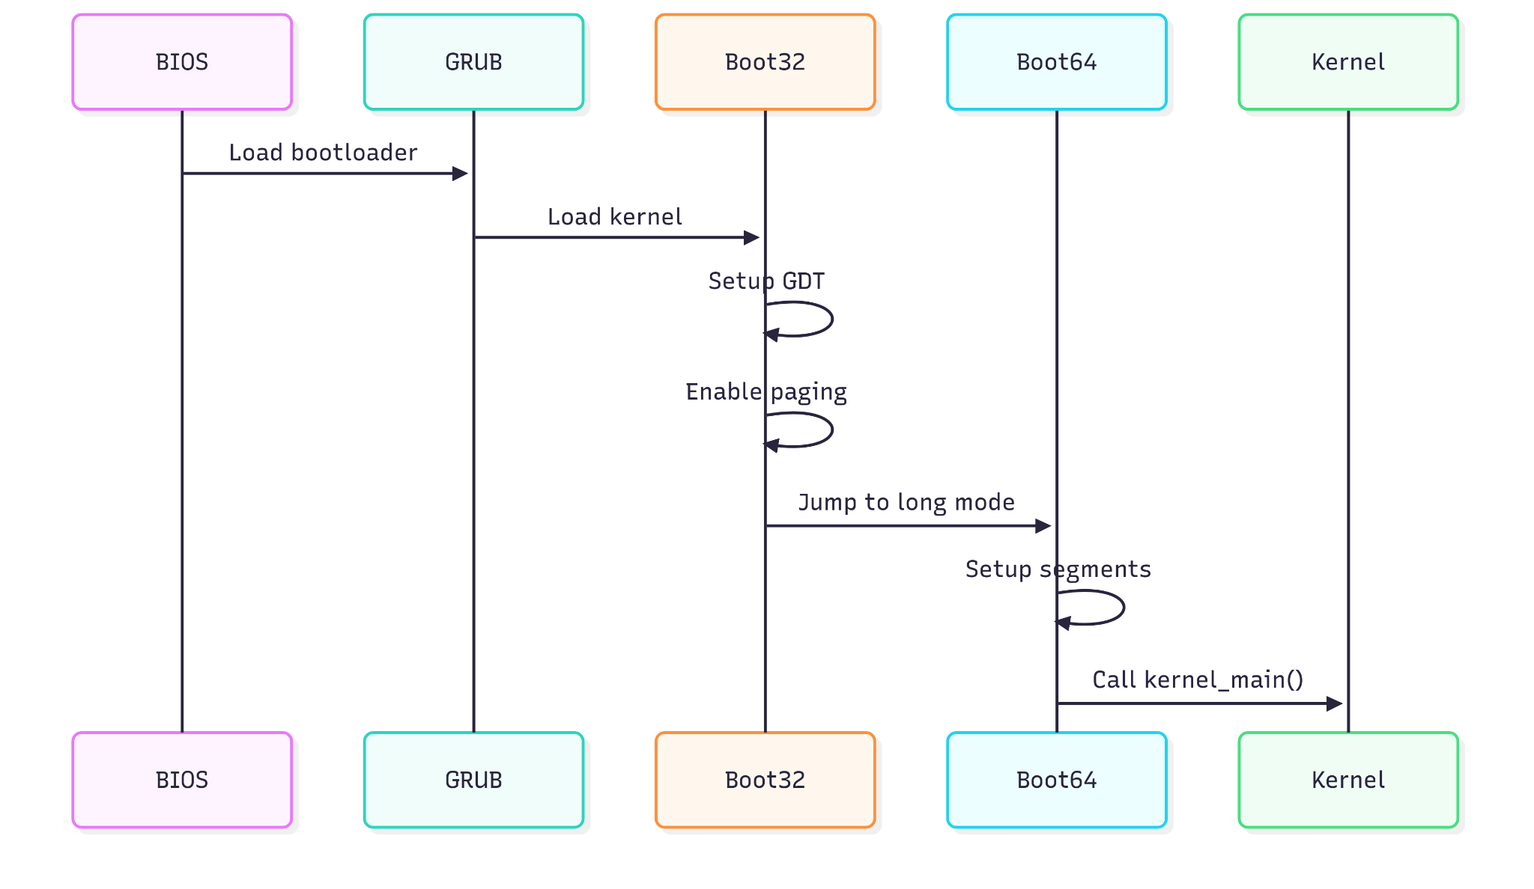

Stage 1: GRUB Bootloader

Multiboot2 Header
section .multiboot_header
header_start:
dd 0xe85250d6 ; Magic number
dd 0 ; Architecture (i386)
dd header_end - header_start ; Header length
dd 0x100000000 - (0xe85250d6 + 0 + (header_end - header_start)) ; Checksum

; End tag
dw 0
dw 0
dd 8
header_end:

Stage 2: 32-bit Bootstrap (main.asm)

System Verification
- Multiboot Compliance: Verify EAX = 0x36d76289
- CPUID Support: Test EFLAGS.ID bit manipulation
- Long Mode Support: Check CPUID extended function 0x80000001

Memory Setup
setup_page_tables:
; Setup 4-level paging for x86_64
mov eax, page_table_l3
or eax, 0b11 ; Present, writable
mov [page_table_l4], eax

; Map first 1GB with 2MB pages
mov ecx, 0
.loop:
mov eax, 0x200000 ; 2MB page size
mul ecx
or eax, 0b10000011 ; Present, writable, huge page
mov [page_table_l2 + ecx * 8], eax
inc ecx
cmp ecx, 512
jne .loop

Long Mode Transition
- Load page tables: Set CR3 register
- Enable PAE: Set CR4.PAE bit
- Enable Long Mode: Set IA32_EFER.LME bit
- Enable paging: Set CR0.PG bit
- Load GDT: Load 64-bit GDT
- Far jump: Jump to 64-bit code segment

Stage 3: 64-bit Initialization (main64.asm)
long_mode_start:
; Clear segment registers for 64-bit mode
mov ax, 0
mov ss, ax
mov ds, ax
mov es, ax
mov fs, ax
mov gs, ax

call kernel_main
hlt

Stage 4: Kernel Initialization (main.c)

Initialization Sequence
- Memory Management: Initialize heap and allocator
- Display System: Clear screen and set colors
- Input System: Initialize keyboard driver
- Shell Interface: Start command interpreter

Development Guidelines

Code Style Standards

C Programming Standards
- Standard: C11 with GNU extensions
- Naming Convention: snake_case for functions and variables
- Indentation: 4 spaces, no tabs
- Line Length: 80 characters maximum
- Comments: Doxygen-style documentation

Example Function Documentation
/**
* @brief Allocates memory from kernel heap
* @param size Number of bytes to allocate
* @return Pointer to allocated memory, or NULL on failure
* @retval NULL Out of memory or invalid size
* @note Memory is aligned to 16-byte boundaries
* @warning Caller must check return value for NULL
* @see kfree() for memory deallocation
*/
void* kmalloc(size_t size);

Assembly Standards
- Syntax: Intel syntax (NASM)
- Comments: Single-line with ;
- Labels: Descriptive names
- Alignment: Align critical sections

Error Handling

Return Value Conventions
- Success: Return 0 or valid pointer
- Failure: Return negative value or NULL
- Status Codes: Defined error constants
// Error code definitions
#define GRANTOS_SUCCESS 0
#define GRANTOS_ENOMEM -1 // Out of memory
#define GRANTOS_EINVAL -2 // Invalid argument
#define GRANTOS_ENOSYS -3 // Function not implemented

Memory Safety

Best Practices
- Always check malloc returns
- Set pointers to NULL after free
- Validate input parameters
- Use const for read-only parameters
// Good example
void* safe_alloc(size_t size) {
if (size == 0) return NULL;

void* ptr = kmalloc(size);
if (ptr == NULL) {
print_str("ERROR: Memory allocation failed\n");
return NULL;
}

return ptr;
}

Testing Philosophy

Unit Testing
- Test individual functions in isolation
- Mock external dependencies
- Cover edge cases and error conditions

Integration Testing
- Test component interactions
- Verify system behavior under load
- Test error recovery mechanisms

Testing Documentation

Test Environment Setup

QEMU Testing Configuration
# Run with debugging enabled
qemu-system-x86_64 -cdrom dist/x86_64/kernel.iso \
-monitor stdio \
-s -S # GDB debugging support

# Memory debugging
qemu-system-x86_64 -cdrom dist/x86_64/kernel.iso \
-m 256M \
-monitor stdio

GDB Debugging Setup
# Terminal 1: Start QEMU with GDB support
qemu-system-x86_64 -cdrom dist/x86_64/kernel.iso -s -S

# Terminal 2: Connect GDB
x86_64-elf-gdb dist/x86_64/kernel.bin
(gdb) target remote localhost:1234
(gdb) continue

Test Cases

Memory Management Tests
// Test Case 1: Basic allocation
void test_basic_allocation() {
void* ptr = kmalloc(100);
assert(ptr != NULL);
kfree(ptr);
}

// Test Case 2: Zero allocation
void test_zero_allocation() {
void* ptr = kmalloc(0);
assert(ptr == NULL);
}

// Test Case 3: Large allocation
void test_large_allocation() {
void* ptr = kmalloc(1024 * 1024); // 1MB
if (ptr != NULL) {
kfree(ptr);
}
// Should not crash system
}

String Function Tests
void test_string_compare() {
assert(str_compare("hello", "hello") == 0);
assert(str_compare("abc", "def") < 0);
assert(str_compare("xyz", "abc") > 0);
}

Display System Tests
void test_display_functions() {
print_clear();
print_str("Test message\n");
print_str_color("Colored text\n", PRINT_COLOR_RED, PRINT_COLOR_BLACK);
// Visual verification required
}

Performance Benchmarks

Memory Allocator Performance
void benchmark_memory_allocation() {
uint64_t start_time = get_time();

for (int i = 0; i < 1000; i++) {
void* ptr = kmalloc(64);
if (ptr) kfree(ptr);
}

uint64_t end_time = get_time();
print_str("1000 allocations took: ");
// Print timing results
}

Troubleshooting Guide

Common Build Issues

Cross-Compiler Problems
Error: x86_64-elf-gcc: command not found

Solution: Install or properly configure cross-compiler
# Add to PATH
export PATH="$PATH:/path/to/cross-compiler/bin"

# Or install via package manager
sudo apt-get install gcc-multilib

Linker Script Issues
Error: cannot find entry symbol start

Solution: Verify linker script and entry point
- Check linker.ld syntax
- Ensure start symbol is defined in assembly
- Verify section alignment

Runtime Issues

Black Screen on Boot
Possible Causes:
- Bootloader configuration incorrect
- Kernel not loaded properly
- VGA initialization failed
Debug Steps:
- Check GRUB configuration
- Add debug prints in early boot
- Verify multiboot header

System Crash/Triple Fault
Possible Causes:
- Stack overflow
- Invalid memory access
- Interrupt handling issues
Debug Steps:
- Use QEMU monitor: info registers
- Check stack pointer values
- Verify page table setup

Memory Management Issues

Allocation Failures
ERROR: kmalloc returned NULL

Debug Checklist:
- Check available memory with meminfo
- Verify heap initialization
- Look for memory leaks
- Check alignment requirements

Double Free Detection
void debug_kfree(void* ptr) {
if (ptr == NULL) return;

// Add magic number checking
block_t* block = (block_t*)ptr - 1;
if (block->magic != BLOCK_MAGIC) {
print_str("ERROR: Double free detected!\n");
return;
}

kfree(ptr);
}

QEMU-Specific Issues

Emulator Hangs
- Check for infinite loops in kernel
- Verify interrupt handling
- Use QEMU monitor commands

Performance Issues
- Increase allocated memory: -m 512M
- Enable KVM acceleration: -enable-kvm
- Use appropriate CPU model: -cpu host

License
MIT License

Copyright (c) 2024 GrantOS Project

Permission is hereby granted, free of charge, to any person obtaining a copy
of this software and associated documentation files (the "Software"), to deal
in the Software without restriction, including without limitation the rights
to use, copy, modify, merge, publish, distribute, sublicense, and/or sell
copies of the Software, and to permit persons to whom the Software is
furnished to do so, subject to the following conditions:

The above copyright notice and this permission notice shall be included in all
copies or substantial portions of the Software.

THE SOFTWARE IS PROVIDED "AS IS", WITHOUT WARRANTY OF ANY KIND, EXPRESS OR
IMPLIED, INCLUDING BUT NOT LIMITED TO THE WARRANTIES OF MERCHANTABILITY,
FITNESS FOR A PARTICULAR PURPOSE AND NONINFRINGEMENT. IN NO EVENT SHALL THE
AUTHORS OR COPYRIGHT HOLDERS BE LIABLE FOR ANY CLAIM, DAMAGES OR OTHER
LIABILITY, WHETHER IN AN ACTION OF CONTRACT, TORT OR OTHERWISE, ARISING FROM,
OUT OF OR IN CONNECTION WITH THE SOFTWARE OR THE USE OR OTHER DEALINGS IN THE
SOFTWARE.

Contributing

How to Contribute
- Fork the repository
- Create a feature branch
- Follow coding standards
- Write tests for new features
- Update documentation
- Submit a pull request

Reporting Issues
- Use GitHub issues
- Include system information
- Provide reproduction steps
- Include relevant logs

Development Workflow
- Check existing issues
- Discuss major changes first
- Write clean, documented code
- Test thoroughly
- Update documentation

Document Version: 1.0
Last Updated: 2024
Authors: GrantOS Development Team
sContact: [Project Repository]

This documentation is maintained as part of the GrantOS project. For the latest version, please refer to the project repository.

